Supplementary information
Field assisted sintering and spark plasma texturing of Nd-Fe-B magnets with anisotropic magnetic properties
M. Keszler, I. Radulov, F. Maccari, T. Mutuk, M. Krengel, O. Guillon, O. Gutfleisch, M. Bram

Supplementary information to Section 2.3
Hot-compaction of MQU-F was performed in FAST/SPS device HP-D10 (FCT Systeme GmbH, Germany), using a standard FAST/SPS graphite die (graphite type R7710, SIGRAFINE, SGL Carbon GmbH, Germany) with an inner diameter of 10 mm. A graphite foil with a thickness of 0.35 mm (type SIGRAFLEX, SGL Carbon GmbH, Germany) was inserted in the mold. Then, the mold was filled with 5 g of MQU-F powder, resulting in a 16 mm tall close-packed powder column (calculated tap density in the mold ca. 51 %).

Based on the experimental results obtained during the hot deformation (described in detail later in this manuscript), it was found out that residual porosity of the pre-sintered samples has negative impact on the microstructure evolution. Therefore, full densification of the pre-sintered compacts was aspired in this experimental series.

Due to the limited strength of the graphite tool, maximal pressure of 50 MPa can be applied during the process. Usually, to ensure good densification and formability while hot compaction of nanocrystalline Nd-Fe-B powder at such low pressure requires elevated temperatures, higher than the melting point of the grain boundary phase. However, the temperature should be kept below 800°C, as heat excess triggers the abnormal grain growth, as shown by Hioki [Hioki 2021]. To define the optimal temperature, we carried out a simple displacement test, where hot compaction was performed under continuous heating up to 750°C, heating rate of 75°C/min and contact pressure of 38 MPa. As it can be seen in Figure S1a, the optimal temperature lies in the range 650 to 750°C, where the grain boundary phase is molten, a transient liquid phase forms and acts as a lubricant supporting the densification and alignment process [Grieb 1992]. Based on those results, it was decided to perform the hot compaction process at 700°C with ramping rate of 75 K⋅min⁻¹. During the heating step constant pressure of 38 MPa was applied and increased to 50 MPa during the dwell time of 60 s at 700°C. As it can be seen in Figure S1b, this temperature was not high enough to complete the densification process and the resulting sample has ca. 10 % residual porosity (confirmed by density measurement). Therefore, the compaction temperature was increased to 725°C, while all other processing parameters were kept the same. The sample obtained at 725°C is full dense, no grain coarsening and misalignment is visible and the isotropic nanocrystalline microstructure is preserved (see Figure S1c. Magnetic measurements (see Figure S1d) show that the soft magnetic phase in the initial MQU F powder is fully transformed after the hot compaction and the hot compacted sample have isotropic nanocrystalline microstructure.

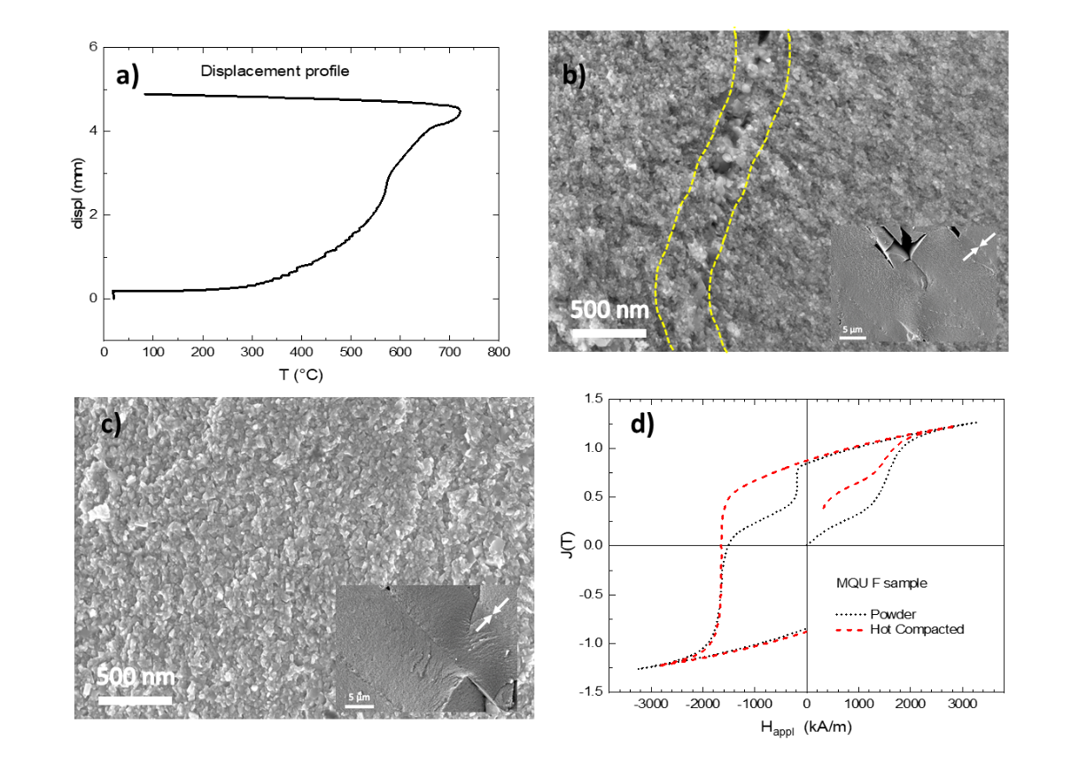
Figure S1: a.) Displacement profile of a test sample, compacted under 38 MPa as described in the text. b., c.) SEM micrograph of fracture surface of a Nd-Fe-B sample pre-sintered by FAST/SPS from melt-spun MQU-F powder processed with heating rate of 75 K⋅min⁻¹, a pressure of 45 MPa and a dwelling time of 60 s at maximum temperature: at 700°C (b.), the sample has 90% of the theoretical density, dotted line indicates the areas where porosity is visible; at 725°C (c.), the sample has > 99% of the theoretical density, all ribbons are aligned, no grain coarsening and misalignment is visible and isotropic nanocrystalline microstructure is preserved. d.) Magnetic properties of the MQU F powder as loose powder and as hot compacted at 725°C.

Supplementary information to Section 3.2
Figure S2 shows that for sample HDS 701 the curves representing the magnetic properties at the centre and at the edge practically coincidence. The same trend was observed for the other samples (respective curves not shown here).
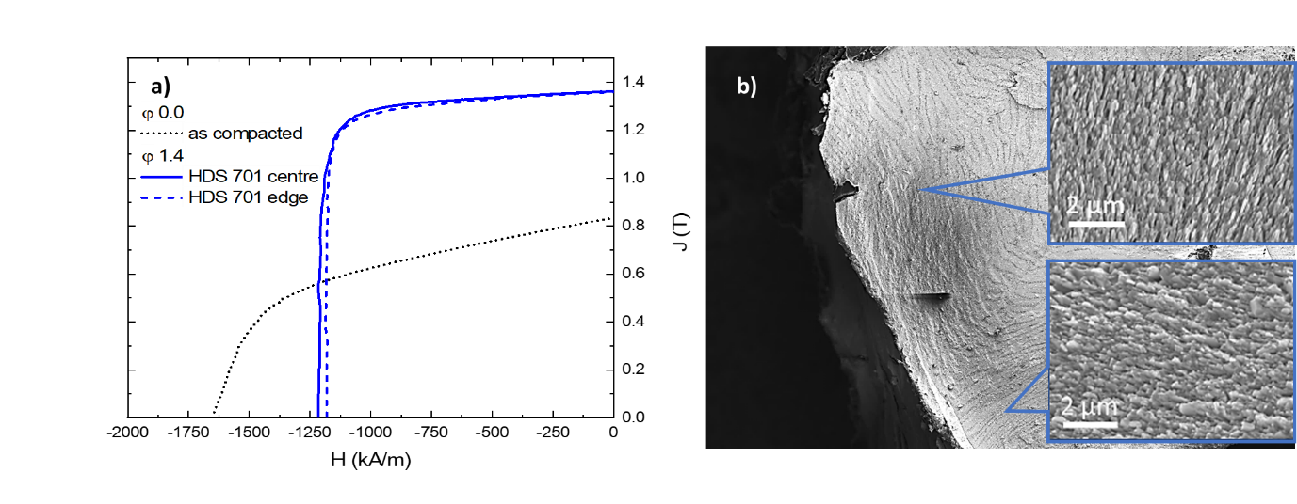
Figure S2: a) Magnetization curves for sample HDS 701 measured on specimens cut from the center (solid line) and the edge (dashed line) of sample as described in the text; b.) Overview SEM image of sample HDS 791 with well pronounced grain misalignment due to the low density of the compacts.

As shown in Figure XX, the best performing sample HDS701 has a remanence of 1.38 T and was obtained at deformation temperature of 750°C under applied pressure of 70 MPa and ramping speed of 75 K⋅min⁻¹. As described in the experimental section, magnetic measurements were performed on rectangular specimens cut from center and edge of the sample. As shown in Figure XX a), for sample HDS 701 both curves practically coincide. For simplification only the curve for the central specimen is shown on Figure xx a) and b). As shown in on Figure xx a) the samples deformed under pressure 50 and 60 MPa have same remanence, but lower coercivity which can be explained with the not fully finalized deformation and consequently worse alignment. Further increase of the deformation pressure to 80 MPa results again in lower coercivity (Figure xx b). As discussed above, SEM micrographs show grain coarsening in this sample. By decreasing the deformation temperature to 725°C we manage to partially overcome this problem (HDS 802 in Figure xx b). This result indicates that good texturing of the grains can be achieved also by hot deformation at relatively low pressure, however magnetic properties are extremely sensitive to all process parameters.

Literature
[Hioki 2021] K. Hioki, High performance hot-deformed Nd-Fe-B magnets (Review), Sci. Techn. Adv. Mat. 22 (2021) 72 – 84.

